**What is SOAP UI?**

* SOAP UI is the leading open source cross-platform API[Testing](https://www.guru99.com/software-testing.html)tool
* SOAPUI allows testers to execute automated functional, regression, compliance, and load tests on different Web API.
* SOAPUI supports all the standard protocols and technologies to test all kinds of API's.
* SOAPUI interface is simple that enables both technical and non-technical users to use seamlessly.

**Why use SOAPUI?**

SOAPUI is not just a functional [Api Testing](https://www.guru99.com/api-testing.html) tool but also lets us perform non-functional testing such as performance and security test.

Let us discuss the 5 important features of SOAPUI

**1) Functional Testing**

* A powerful tool allows testers to write Functional API Tests in SoapUI
* Supports Drag-Drop feature which accelerates the script development
* Supports debugging of tests and allows testers to develop data driven tests.
* Supports Multiple Environments - Easy to switch between QA, Dev and Prod Environments
* Allows advanced scripting (tester can develop their custom code depending on the Scenario)

**2) Security Testing**

* Has the capability to perform a complete set of vulnerability scan.
* Prevents[SQL](https://www.guru99.com/sql.html)Injection to secure the databases
* Scans for Stack overflows that are caused by documents huge in size
* Scans for Cross Site Scripting, which usually occurs when service parameters are exposed in messages.
* Performs Fuzzing scan and Boundary scan to avoid erratic behavior of the services.

**3) Load Testing**

* Distribute the Load Tests across any number of loadUI Agents.
* Simulate high volume and real-world load testing with ease.
* Allows Advanced custom reporting to capture performance parameters.
* Allows End-to-End System Performance Monitoring

**4) Supported Protocols/Technologies:**

SoapUI has the most comprehensive Protocol Support

[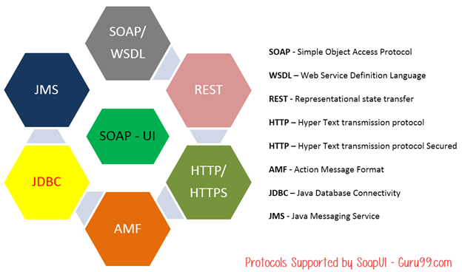](https://cdn.guru99.com/images/1-2015/010915_0948_Introductio2.png)

**5) SOAP-INTEGRATION with Other Automation Tools:**

SoapUI integrated very well with popular tools

* Maven

[What is SoapUI? Introduction to SoapUI Testing](https://cdn.guru99.com/images/1-2015/010915_0948_Introductio5.png)

Apache **Maven** is a software project management tool that can manage a project's build, reporting and documentation from a central repository. Maven can also execute SOAPUI tests within Maven Build using simple commands.

* HUDSON

[What is SoapUI? Introduction to SoapUI Testing](https://cdn.guru99.com/images/1-2015/010915_0948_Introductio6.png)

HUDSON, a[Java](https://www.guru99.com/java-tutorial.html)based Continous integration tool and integrates with tools such as CVS, Subversion, Git, Perforce, Clearcase, and RTC. SOAPUI also integrates with HUDSON, which helps us to spot bugs quickly for each and every commit by the developers.

* JUnit

[What is SoapUI? Introduction to SoapUI Testing](https://cdn.guru99.com/images/1-2015/010915_0948_Introductio7.png)

JUnit is a [Unit Testing](https://www.guru99.com/unit-testing-guide.html) framework built in Java, which can control the flow of tests from SOAPUI as well.

* Apache - Ant

[What is SoapUI? Introduction to SoapUI Testing](https://cdn.guru99.com/images/1-2015/010915_0948_Introductio8.png)

[Apache](https://www.guru99.com/apache.html)Ant, a Java library which is a command-line tool that helps in building software. Using SOAP UI's Command line, we can execute tests within an ANT Automated Build.

**SOAP UI Vs Selenium:**

Let's compare SoapUI with Selenium

|  |  |
| --- | --- |
| **SOAP UI** | **Selenium** |
| SOAP UI is NOT used for User Interface Testing. It is only used for WebAPI or WebService Testing | Selenium is used for User Interface Testing. |
| Capability to test the data sent and received between the web browser and a web server. Can test the protocols/technologies such as REST, SOAP. | Selenium cannot test protocols, but they can test the UI behavior. |
| Able to perform functional, load and [Security Testing](https://www.guru99.com/what-is-security-testing.html) of the above-mentioned technologies. | Selenium can perform only[Functional Testing](https://www.guru99.com/functional-testing.html). [Performance Testing](https://www.guru99.com/performance-testing.html) to some extent because we can track execution time with regards to the performance but cannot test multi user and multi tenancy.[Selenium](https://www.guru99.com/selenium-tutorial.html)certainly cannot be used for security testing. |
| It is PROTOCOL Dependent and NOT browser dependent. | Selenium depends on the browser capabilities. |

**Soap Ui: Configuring**

Let us first understand the project structure in SOAP UI.

* First step in SOAP UI is to create a workspace. There can be several projects associated with a workspace. Users can create more than one workspace. In SOAP UI Pro version, we can seamlessly switch environments to map it to different end points.
* For Each project, we can create several test suites.
* For Each Test Suite, there can be several test cases attached to it.
* For Each Test Case, there can be several test steps associated with it.

Below is the pictorial representation of a workspace structure in SOAP-UI.

# SoapUI Tutorial: Create a Project, Test Suite, TestCase

### Understanding the SOAP Protocol

Before we create an SOAPUI Test case, let us understand basics about the SOAP Protocol. This will help you use SOAP UI to test SOAP requests and response effectively.

SOAP stands for **S**imple **O**bject **A**ccess **P**rotocol. Below are the properties of a SOAP Protocol.

* It is an XML-based protocol for communicating between two different systems.
* It is a platform and language independent. Hence, a system developed using[Java](https://www.guru99.com/java-tutorial.html)can communicate with a system developed in.NET.
* SOAP requests/response are transported via HTTP.

# Assertions in SoapUI: Complete Tutorial

### What Is An Assertion?

* Assertion means act of affirming or stating something. It can also be interpreted as check point or a validation point.
* Once a request is sent to a web server a response is received. We need to validate if the response contains the data that we expect. In order to validate the response, we need to use assertions.

### Types Of Assertion

There are various ways of asserting a response; however we will focus on the commonly used Assertions types while validating a response. Below are the ones that are available in Open Source version of SoapUI.

1. Property Content
2. Compliance Status Standard
3. Script
4. SLA
5. JMS
6. Security

[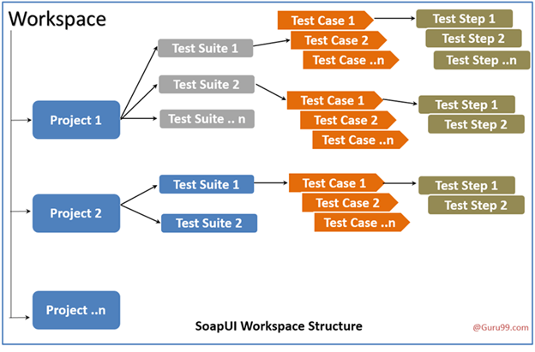](https://cdn.guru99.com/images/1-2015/010915_1028_SOAPUIInsta17.png)